2015年高考英语试题全国课标卷Ⅱ解析
【试卷总评】
试卷总体难度适中，符合立足基础，突出语境的思想，与考纲的要求一致。中低难度的题占试卷的80%以上。本试卷区分度最大的还应该是完型填空，因为本篇完型是夹叙夹议的文章。写作以说明文为主，和去年一致。阅读题和其他题型与往年难度持平。
第Ⅰ卷
第一部分 听力（共两节，满分30分）略
第二部分 阅读理解（共两节，满分40分）
A
My color television has given me nothing but a headache. I was able to buy it a little over a year ago because I had my relatives give me money for my birthday instead of clothes that wouldn’t fit. I let a salesclerk fool me into buying a discontinued model. I realized this a day later, when I saw newspaper advertisements for the set at seventy-five dollars less than I had paid. The set worked so beautiful when I first got it home that I would keep it on until stations signed off for the night. Fortunately, I didn’t get any channels showing all-night movies or I would never have gotten to bed.
Then I started developing a problem with the set that involved static(静电) noise. For some reason, when certain shows switched into a commercial, a loud noise would sound for a few seconds. Gradually, this noise began to appear during a show, and to get rid of it, I had to change to another channel and then change it back. Sometimes this technique would not work, and I had to pick up the set and shake it to remove the sound. I actually began to build up my arm muscles(肌肉) shaking my set.
When neither of these methods removed the static noise, I would sit helplessly and wait for the noise to go away. At last I ended up hitting the set with my first, and it stopped working altogether. My trip to the repair shop cost me $62, and the sit is working well now, but I keep expecting more trouble.[来源:学#科#网Z#X#X#K]
21. Why did the author say he was fooled into buying the TV set?
- He got an older model than he had expected.
- He couldn’t return it when it was broken.
- He could have bought it at a lower price.
- He failed to find any movie shows on it.
22. Which of the following an best replace the phrase “signed off” in paragraph 1?
- ended all their programs
- provided fewer channels
- changed to commercials
- showed all-night movies
23. How did the author finally get this TV set working again?
- By shaking and hitting it
- By turning it on and off
- By switching channels
- By having it repaired
24. How does the author sound when telling the story?
- Curious
- Anxious
- Cautious
- Humorous
【答案】
21. C
22. A
23. D
24. D
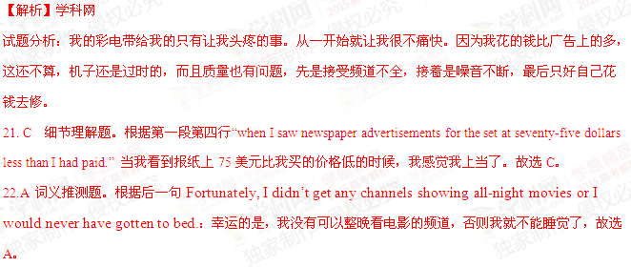23.D 细节理解题。根据文章最后一段的My trip to the repair shop cost me $62，可知作者由于用拳头砸电视，导致电视没了噪音，也什么都不出了。最后只好自己花钱去修理店修电视机，共花了62美元，故选D。
24.D推理判断题。根据开头Fortunately, I didn’t get any channels showing all-night movies or I would never have gotten to bed.意思是说：看不了电视节目就可以睡觉；中间还说I actually began to build up my arm muscles(肌肉) shaking my set.意思是：晃动电视的同时还锻炼了胳膊上肌肉，可知作者很诙谐幽默。故选D。
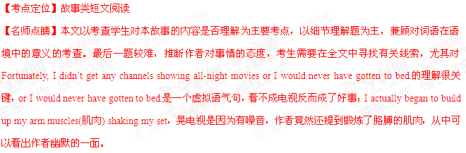B
Your house may have an effect on your figure. Experts say the way you design your home could play a role in whether you pack on the pounds or keep them off. you can make your environment work for you instead of against you. Here are some ways to turn your home into part of your diet plan.
Open the curtains and turn up the lights. Dark environments are more likely to encourage overeating, for people are often less self-conscious(难为情) when they’re in poorly lit places – and so more likely to eat lots of food. If your home doesn’t have enough window light, get more lamps and flood the place with brightness.
Mind the colors. Research suggests warm colors fuel our appetites. In one study, people who ate meals in a blue room consumed 33 percent less than those in a yellow or red room. Warm colors like yellow make food appear more appetizing, while cold colors make us less hungry. So when it’s time to repaint, go blue.
Don’t forget the clock – or the radio. People who eat slowly tend to consume about 70 fewer calories(卡路里) per meal than those who rush through their meals. Begin keeping track of the time, and try to make dinner last at 30 minutes. And while you’re at it, actually sit down to eat. If you need some help slowing down, turning on relaxing music. It makes you less likely to rush through a meal.
Downsize the dishes. Big serving bowls and plants can easily makes us fat. We eat about 22 percent more when using a 12-inch plate instead of a 10-inch plate. When we choose a large spoon over a smaller one, total intake(摄入) jumps by 14 percent. And we’ll pour about 30 percent more liquid into a short, wide glass than a tall, skinny glass.
25. The text is especially helpful for those who care about ____.
- their home comforts
- their body shape
- house buying
- healthy diets
26. A home environment in blue can help people ____.
- digest food better
- reduce food intake
- burn more calories
- regain their appetites
27. What are people advised to do at mealtimes?
- Eat quickly.
- Play fast music
- Use smaller spoons
- Turn down the lights
28.What can be a suitable title for the text?
- Is Your House Making You Fat?
- Ways of Serving Dinner
- Effects of Self-Consciousness
- Is Your Home Environment Relaxing?
【答案】
25. B
26. B
27.C
28.A
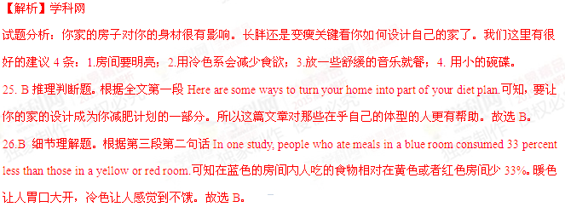27.C 推理判断题。本题是在考查考生是否理解了4条建议。第4段People who eat slowly tend to consume about 70 fewer calories(卡路里) per meal than those who rush through their meals.，说明吃得慢就吃得少，吃得快就多，故A错；If you need some help slowing down, turning on relaxing music.说明放舒缓的音乐可以让人吃得慢，反之则快，故B错；第二段Dark environments are more likely to encourage overeating,由此可知房间暗会增加饮食，所以D错；最后一段When we choose a large spoon over a smaller one, total intake(摄入) jumps by 14 percent.用大勺和小勺吃饭，相差14%，故选C。
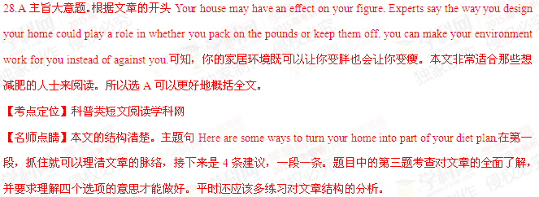C
More students than ever before are taking a gap year(间隔年) before going to university. It used to be the “year off” between school and university. The gap-year phenomenon originated(起源) with the months left over to Oxbridge applicants between entrance exams in November and the start of the next academic year.
This year, 25,310 students who have accepted places in higher education institutions have put off their entry until next year, according to statistics on university entrance provided by the University and College Admissions Service (UCAS).
That is a record 14.7% increase in the number of students taking a gap year. Tony Higgins from UCAS said that the statistics are good news for everyone in higher education. “Students who take a well-planned year out are more likely to be satisfied with, and complete, their chosen course. Students who take a gap year are often more mature and responsible,” he said.
But not everyone is happy. Owain James, the president of the National Union of Students (NUS), argued that the increase is evidence of student hardship – young people are being forced into earning money before finishing their education. “New students are now aware that they are likely to leave university up to￡15,000 in debt. It is not surprising that more and more students are taking a gap year to earn money to support their study for the degree. NUS statistics show that over 40% of students are forced to work during term time and the figure increases to 90% during vacating periods,” he said.
29. What do we learn about the gap year from the text?
- It is flexible in length.
- It is a time for relaxation
- It is increasingly popular
- It is required by universities
30. According to Tony Higgins. students taking a gap year ____.
- are better prepared for college studies[来源:Zxxk.Com]
- know a lot more about their future job
- are more likely to leave university in debt
- have a better chance to enter top universities
31. How does Owain James feel about the gap-year phenomenon?
- He’s puzzled
- He’s worried
- He’s surprised
- He’s annoyed[来源:学科网]
32.What would most students do on their vacation according to NUS statistics?
- Attend additional courses.
- Make plans for the new term
- Earn money for their education
- Prepare for their graduate studies
【答案】
29. C
30.A
31. B
32.C
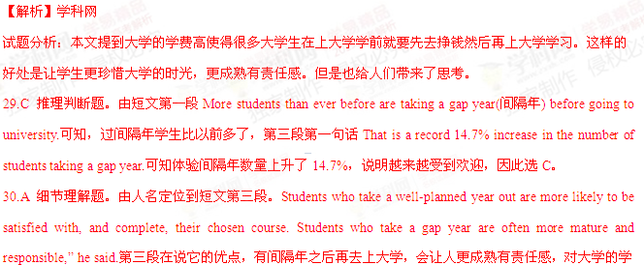习有帮助。故选A。
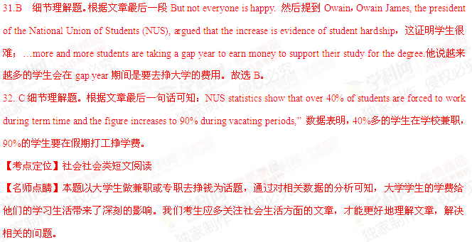D
Choose Your One-Day-Tours!
Tour A - Bath &Stonehenge: including entrance fees to the ancient Roman bathrooms and Stonehenge -￡37 until 26 March and ￡39 thereafter.
Visit the city with over 2,000 years of history and Bath Abbey, the Royal Crescent and the Costume Museum, Stonehenge is one of the world's most famous prehistoric monuments dating back over 5,000 years.
Tour B - Oxford & Startford including entrance fees to the University St Mary's Church Tower and Anne Hathaway's -￡32 until 12 March and ￡36 thereafter
Oxford: Includes a guided tour of England's oldest university city and colleges. Look over the "city of dreaming spires(尖顶）"from St Mary’s Church Tower. Stratford: Includes a guided tour exploring much of the Shakespeare wonder.
Tour C - Windsor Castle &Hampton Court including entrance fees to Hampton Court Palace -￡34 until 11 March and ￡37 thereafter.
Includes a guided tour of Windsor and Hampton Court, Henry VILL's favorite palace. Free time to visit Windsor Castle(entrance fees not included).With 500 years of history, Hampton Court was once the home of four Kings and one Queen. Now this former royal palace is open to the public as a major tourist attraction. Visit the palace and its various historic gardens, which include the famous maze(迷宫)where it is easy to get lost!
Tour D -Cambridge including entrance fees to the Tower of Saint Mary the Great -￡33 until 18 March and ￡37 thereafter.
Includes a guided tour of Cambridge, the famous university town, and the gardens of the 18th century.
33. Which tour will you choose if you want to see England’s oldest university city?
- Tour A
- Tour B
- Tour C
- Tour D
34. Which of the following tours charges the lowest fee on 17 March?
- Windsor Castle & Hampton Court
- Oxford & Stratford
- Bath & Stonehenge
- Cambridge
35. Why is Hampton Court a major tourist attraction?
- It used to be the home of royal families
- It used to be a well-known maze
- It is the oldest palace in Britain
- It is a world-famous castle
【答案】
33. B
34. D
35. A
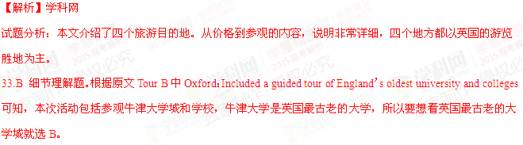34.D细节理解题。根据每一部分的价格介绍：Tour A￡37 until 26 March and ￡39 thereafter.到3月17日为￡37，3月26日后还会涨价；Tour B-￡32 until 12 March and ￡36 thereafter为3月12日前价格为￡32，12日后为￡36；Tour C-￡34 until 11 March and ￡37 thereafter.为3月11日前价格为￡34，11日后为￡37；Tour D￡33 until 18 March and ￡37 thereafter.为3月18日前价格为￡33，18日后为￡37；本题文3月17号费用最低的，当然是￡33，故选D。
35.A细节理解题。根据With 500 years of history, Hampton was once the home of four Kings and one Queen Now this former royal palace is open to the public as a major tourist attraction.判断，人们去参观的主要原因是因为这是有着500年历史的前皇家宫殿，答案为A。
【考点定位】广告类短文阅读。
【名师点睛】本文是广告类阅读。广告类的题其实只要我们根据问题去找答案就可以，因为题目基本上都是细节理解题。本题中第34小题需要做一些理解和对比。一方面对价格的理解要准确，另一方面要知道题目问的是哪一天价格最低，这样，实际上需要一个对比才能完成得好。
第二节（（共5小题；每小题2分，满分10分）
根据短文内容，从短文后的选项中选出能填入空白处的最佳选项。选项中有两项为多余选项。
Training for a marathon requires careful preparation and steady, gradual increases in the length of the runs. 36 , buy the best-fitting running shoes you can find. No one can say which brand will work best for you or feel best on your feet, so you have to rely on your experience and on the feel of each pair as you shop. When you have found shoes that seem right, walk in them for a few days to double-check the fit. 37 . As always, you should stretch(伸展) at least ten minutes before each run to prevent injuries.
During the first week, do not think about distance, but run five minutes longer each day. 38 , it is wise to take a day off to rest. But during the next week, set a goal of at least a mile and a half per run. 39 . After two weeks, start timing yourself. 40 . Depending on the kind of race you plan to enter, you can set up a timetable for the remaining weeks before the race.
- After six days
- For a good marathon runner
- Before you begin your training
- With each day, increase the distance by a half mile
- If they still feel good, you can begin running in them
- Time spent for preparation raises the quality of training
- Now you are ready out a goal of improving distance and time
【答案】
36.C
37. E
38.A
39. D
40. G
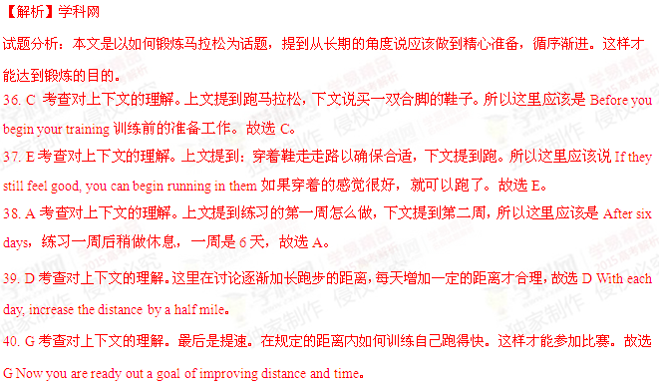【考点定位】生活类短文阅读。
【名师点睛】本文是给体育锻炼提建议。这是七选五短文常考的类型。这类题的思路清楚，考生容易把握文章的结构，为填充缺失的信息打下好的基础。本题的首句是关键的理解点。下文都围绕这句展开。所以填对的根据在于正确理解全文和摸清文章的脉络。
第三部分英语知识运用（共两节，满分45分）
第一节完形填空（共20小题；每小题1．5分，满分30分）[来源:学.科.网Z.X.X.K]
阅读下面短文，从短文后各题所给的四个选项（A, B, C和D）中，选出可以填入空白处的最佳选项，并在答题卡上将该项涂黑。
Where do you go when you want to learn something? School? A friend? A tutor? These are all 41 places of learning. But it may well be that the learning you really want 42 somewhere else instead. I had the 43
of seeing this first hand on a 44 .
My daughter plays on a recreational soccer team. They did well this season and so 45 a tournament, which normally was only for more skilled club teams. This led to some 46 experiences on Saturday as they played against teams 47 trained. Through the first two games, her 48 did not get one serious shot on goal. As a parent, I 49 seeing my daughter playing her best, 50 still defeated.
It seemed that something clicked with the 51 between Saturday and Sunday. When they 52 for their Sunday game, they were 53 different. They had begun to integrate (融合) the kinds of play and teamwork they had 54 the day before into their 55 . They played aggressively and 56 scored a goal.
It 57 me that playing against the other team was a great 58 moment for all the girls on the team. I think it is a general principle. 59 is the best teacher. The lessons they learned may not be 60 what they would have gotten in school, but are certainly more personal and meaningful, because they had to work them out on their own.
41.A. public B. traditional C. official D. special
42.A. passes B. works C. lies D. ends
43. A. dream B. idea C. habit D. chance
44.A. trip B. holiday C. weekend D. square
45. A. won B. entered C. organized D. watched
46. A. painful B. strange C. common D. practical
47. A. less B. poorly C. newly D. better
48.A. fans B. tutors C. class D. team
49.A. imagined B. hated C. avoided D. missed
50. A. if B. or C. but D. as
51.A. girls B. parents C. coaches D. viewers
52. A. dressed B. showed up C. made up D. planned
53. A. slightly B. hardly C. basically D. completely
54.A. seen B. known C. heard D. read
55. A. styles B. training C. game D. rules
56. A. even B. still C. seldom D. again
57.A. confused B. struck C. reminded D. warned
58. A. touching B. thinking C. encouraging D. learning
59.A. Experience B. Independence C. Curiosity D. Interest
60. A. harmful to B. mixed with C. different from D. applied to
【答案】
41. B
42. C
43. D
44. C
45. B
46. A
47. D
48. D
49. B
50. C
51. A
52. B
53. D
54. A
55. C
56. A
57. B
58. D
59. A
60. C
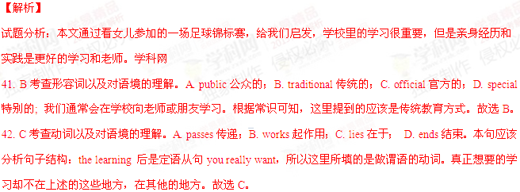43. D考查名词以及对语境的理解。A. dream梦想；B. idea想法；C. habit习惯；D. chance机会。根据下文的故事可知，我女儿的经历让我有机会看到了这样的学习。故选D。
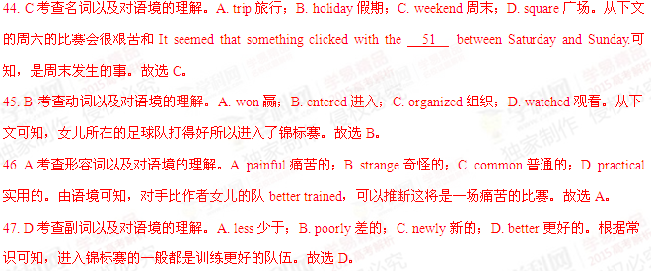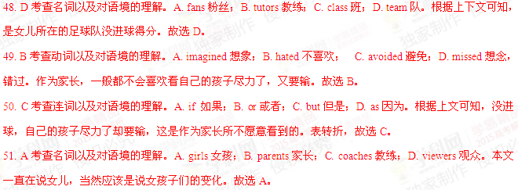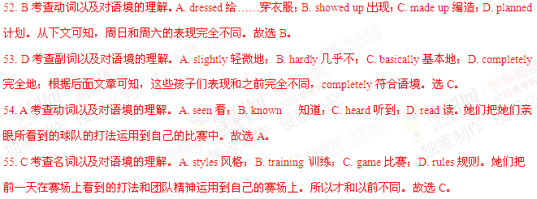56. A考查副词以及对语境的理解。A. even甚至；B. still仍然；C. seldom很少；D. again又。她们和前一场比，打得有闯劲，甚至还得了一分。故选A。
57. B考查动词以及对语境的理解。A. confused使困惑；B. struck击打；C. reminded提醒； D. warned警告。It strike sb.是固定句式，意思是让某人突然想到，符合语境。故选B。
58. D考查动词以及对语境的理解。A. touching接触；B. thinking思考；C. encouraging鼓励；D. learning学习。和另一个队比赛也是一个很好的学习的机会。和文章的开头相呼应。故选B。
59. A考查名词以及对语境的理解。A. Experience经历；B. Independence独立；C. Curiosity好奇；D. Interest兴趣。结合全文的意思可知，经历是最好的老师。故选A。
60. C考查动词以及对语境的理解。A. harmful to对……有伤害；B. mixed with混合；C. different from不同；D. applied to应用于。亲身体验得到的东西和在学校里学到的可能不同，但是更有个性有意义。故选C。
【考点定位】教育类短文阅读。
【名师点睛】本文是一篇夹叙夹议的短文。这样的短文是大多数考生难以把握的。不过，这样的文章通常在开头和结尾处点睛，评论。中间叙事。以第三人称的形式转述，一定会有个人的观点包括在内。所以考生要认真分析是什么事引发了怎样的思考或评论，即事件和议论是两条线。另外平时多做多分析一些这类题会有很大的帮助。
第Ⅱ卷
第三部分英语知识运用（共两节，满分45分）
第二节（共10小题，每小题1.5分，满分15分）
阅读下面材料，在空白处填入适当的内容（1个单词）或括号内单词的正确形式。
The adobe dwellings (土坯房) 61 （build）by the Pueblo Indians of the American Southwest are admired by even 62 most modern of architects and engineers. In addition to their simple beauty, what makes the adobe dwellings admirable is their 63 (able) to “air condition” a house without 64 ( use) electric equipment. Walls made of adobe take in the heat from the sun on hot days and give out that heat 65 ( slow) during cool nights, thus warming the house. When a new day breaks, the walls have given up their heat and are now cold enough 66 (cool) the house during the hot day; 67 the same time, they warm up again for the night. This cycle 68 (go) day after day: The walls warm up during the day and cool off during the night and are thus always a timely offset(抵消) for the outside temperatures. As 69 (nature) architects, the Pueblo Indians figured out exactly 70 thick the adobe walls needed to be to make the cycle work on most days.
【答案】
61.built
62.the
63.ability
64.using
65.slowly[来源:学科网ZXXK]
66.to cool
67.at
68.goes
69.natural
70.how
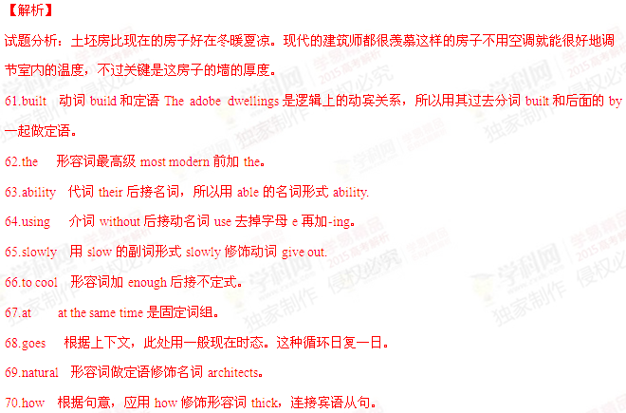【考点定位】语法填空。
【名师点睛】通过阅读完成词形变化以适合文章的内容和上下文的语境。要做对本题，考生在平时应多做语法填空这类的练习以掌握固定句式和词组的在语境中的用法。分析语法是学生的弱项，学生通常是靠语感来完成的。高年级的学生如果掌握好语法，对学好英语，写对句子有很多的好处。
第四部分写作（共两节，满分35分）
第二节短文改错（共10小题；每小题1分，满分10分）
假定英语课上老师要求同桌之间交换修改作文，请你修改你同桌写的以下作文。文中共有10处语言错误，每句中最多有两处。每处错误涉及一个单词的增加、删除或修改。
增加：在缺词处加一个漏字符号（∧），并在其下面写出该加的词。
删除：把多余的词作斜线（\）划掉。
修改：在错的词下划一横线，并在该词下面写出修改后的词。
注意：1. 每处错误及其修改均仅限一词；
2. 只允许修改10处，多者（从第11处起）不计分。
One day , little Tony went to a shopping center with his parent. It was very crowded. Tony saw a toy on a shop window. He liked it so very much that he quickly walked into the shop. After looks at the toy for some time, he turned around and found where his parents were missing. Tony was scared and begun to cry. A woman saw him drying and telling him to wait outside a shop. Five minutes later, Tony saw parents. Mom said,“How nice to see you again! Dad and I were terrible worried. ” Tony promised her that this would never happen again.
【答案】
71. parent改为parents
72. on改为in
73. very去掉
74. looks改为looking
75. where改为that 或者去掉 where
76. begun改为began
77. telling改为told
78. a改为the
79. saw后加his
80. terrible改为terribly
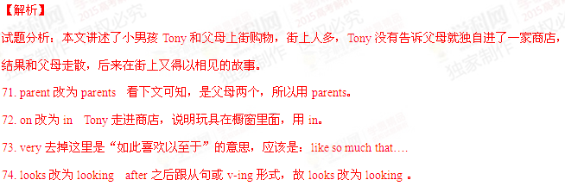75. where改为that 或者去掉 where found后面的宾语从句是陈述句，故where改为that或者去掉where。
第二节 书面表达（满分25分）
86.假如你是李华，计划和同学去敬老院（nursing home）陪老人们国重阳节（the Double Ninth Festival）。请给外教Lucy写封邮件，邀她一同前往，内容包括：
1. 出发及返回时间；
2. 活动：包饺子、表演节目等。
注意：
1. 词数100左右；
2. 可以适当增加细节，以使行文连贯；
3. 结语已为你写好。
__________________________________________________________________________________________________________________________________________________________________________________________________________________________________________________________________________________________________________________________________________________________________________________________________________________________________________________________________________________________
Looking forward to your reply.
Yours
Li Hua
【参考答案】
Dear Lucy,
I’d like to invite you to join us for a visit to the nearby nursing home next Saturday for the Double Ninth Festival. It is the day for the elderly in our culture. We’ll go and make dumplings and cakes with the elderly people there. We’ll also spend some fun time together singing, dancing and playing games, which we hope will make them happy. We should be back around 4 o’clock in the afternoon. If you are able to come with us, please let us know and we’ll wait for you at the gate at 9 in the morning.
Looking forward to your reply.
Yours
Li Hua
